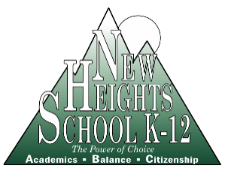
ANNUAL MEETING
NOTICE

April 15, 2019

TO: All Parents and Staff Members of
New Heights School

RE: New Heights School
Annual Meeting and Board of Directors Election

In May of each year New Heights School holds its Annual Meeting. This meeting includes the election of board members, presentations pertaining to various aspects of the school, and other transactions which may properly come before the meeting.

This year the meeting has been scheduled for Wednesday, May 15th, 2019 at 7:00 p.m.

Board meetings are open. You are welcome to attend and meet the New Heights School Board members.

The parents of students enrolled in the school; staff employed at the school; and/or current board members may participate in the election by voting to elect the Board of Directors each year. Members of the Board of Directors are elected to serve two-year terms. This year there are 4 vacancies on the board.

Let us know if you are interested in serving on the NHS Board of Directors:
If you would like to serve on the New Heights School Board of Directors, or know of someone who would be interested, please fill out the attached application form and return it to the school office by May 10th, 2019. The nominees will then be listed on an official election ballot form to be used for voting on May 15th, 2019.

Voting must be done in-person, using an official ballot form. Only members of New Heights School, either a parent or legal guardian of an enrolled student; a current board member; or an employee of New Heights Schools, Inc. may participate in the voting. Each member shall be entitled to cast one voting ballot. Members may not vote by proxy. Cumulative voting shall not be permitted. (In accordance to the NHS Bylaws Article III, Sec. 3.5.)

VOTING HOURS:

8:30 a.m. to 4:00 p.m. Main School Office
6:30 p.m. to 7:00 p.m. Room 105, prior to the Annual Meeting

Attachment: NHS School Board Application Form

